List Folder Files - Code Source

Ai Question
# Source: Provided by [Motasem Essam -> motasem.essam.prototypedoteg.com@gmail.com] on [11/17/2025]
# Data Path: Entities Folder -> Entities Database -> Persons Table -> ID: 1
give me python code to get names of each file with extension in specific folder give me way to select folder by window and list all files with their extensions inside that folder.

Ai Answer
# Source: Chatgpt (GPT‑5 Mini) at [11/17/2025]
Here is a simple and clean way to pick a folder using a Windows dialog and then list all files with their extensions inside that folder.
✅ Option 1 — tkinter (built-in, easiest)
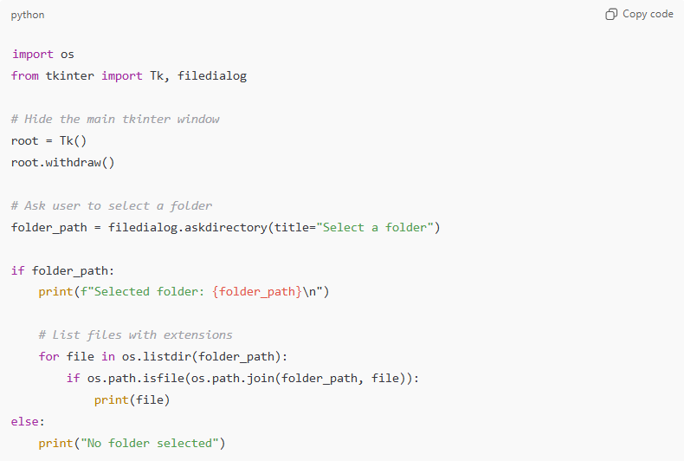
import os
from tkinter import Tk, filedialog

# Hide the main tkinter window
root = Tk()
root.withdraw()

# Ask user to select a folder
folder_path = filedialog.askdirectory(title="Select a folder")

if folder_path:
print(f"Selected folder: {folder_path}\n")

# List files with extensions
for file in os.listdir(folder_path):
if os.path.isfile(os.path.join(folder_path, file)):
print(file)
else:
print("No folder selected")

✅ Option 2 — If you want only files with a specific extension
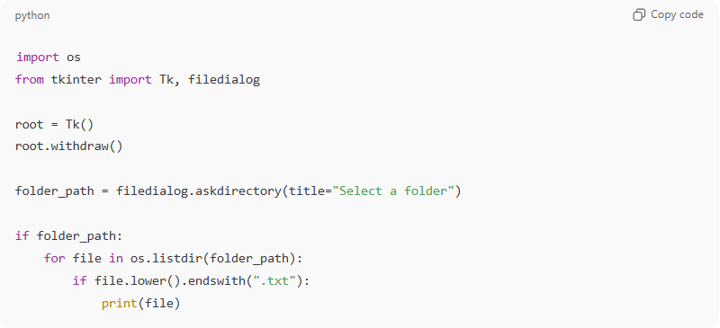
Example: only .txt files.
import os
from tkinter import Tk, filedialog

root = Tk()
root.withdraw()

folder_path = filedialog.askdirectory(title="Select a folder")

if folder_path:
for file in os.listdir(folder_path):
if file.lower().endswith(".txt"):
print(file)

💡 How it works
- filedialog.askdirectory() opens a Windows folder-selection dialog
- os.listdir() gives all items inside the folder
- os.path.isfile() ensures we only print files
- prints full filenames with extensions

If you want, I can also:
✔ return full file paths
✔ recursively list files in all subfolders
✔ filter by multiple extensions
✔ export the list to a CSV or text file
Just tell me!

Ai Question
# Source: Provided by [Motasem Essam -> motasem.essam.prototypedoteg.com@gmail.com] on [11/17/2025]
# Data Path: Entities Folder -> Entities Database -> Persons Table -> ID: 1
how to run python

Ai Answer
# Source: Chatgpt (GPT‑5 Mini) at [11/17/2025]
Here are the simplest ways to run Python, depending on what you prefer.
Choose the one that matches how you want to work:

✅ 1. Run Python from a .py file (most common)
Steps:
- Open Notepad, VS Code, or any editor.
- Save your code as:
your_script.py
- Open Command Prompt (Win + R → type cmd).
- Type:
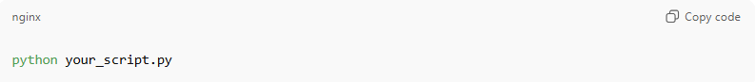
python your_script.py
If your system uses python3, then:
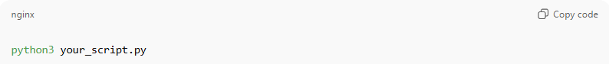
python3 your_script.py

✅ 2. Run Python from IDLE (comes with Python)
- Install Python from python.org
- Open IDLE (it installs automatically)
- You can:
  - type code directly and press Enter
  - or open a file → Run → Run Module (F5)

✅ 3. Run Python in VS Code
- Install Visual Studio Code
- Install Python extension
- Open your .py file
- Press Run ▶ in top-right
or F5

✅ 4. Run Python from Windows PowerShell
Open PowerShell and run:
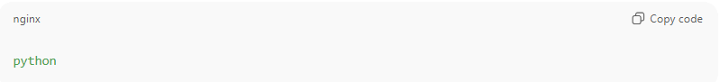
python
(or python3)
You can also run a file:
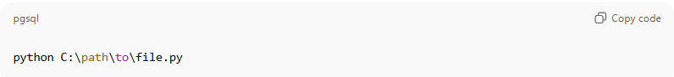
python C:\path\to\file.py

💡 Check if Python is installed
In Command Prompt:
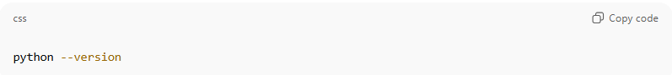
python --version
If it prints something like Python 3.11.3, you're good.

If you want, tell me:
- Your Windows version, and
- How you prefer to run code
…and I’ll guide you step-by-step perfectly for your setup.

